 | AIR RESCUE ASSOCIATION NEWSLETTER |  | VOLUME 79  ISSUE 1  February 2026
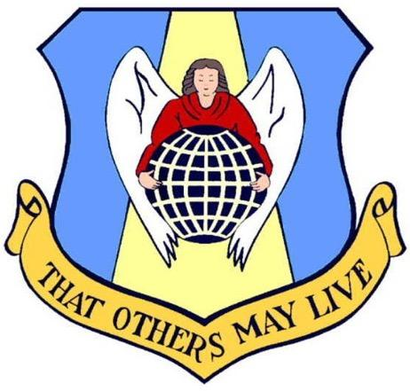
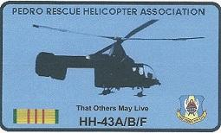
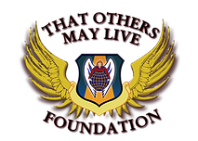

2026 BOARD MEMBERS
Mike Tillema President  Mandy Hutchison Vice President  Brad Dow Secretary  Todd Prejean Treasurer  Bob Remey Historian  Jim Morris Plans & Programs  Gene Manner Public Relations  Bill Payne Editor  Rick Sheets Member-At-Large  Rick Sheets Member-At-Large  Greg Gaunt Member-At-Large  Tony Ray Member-At-Large  Jim Tuthill Member-At-Large |  | Published by the  Air Rescue Association  www.usafrescue.org  Contact:  president@usafrescue.org  info@usafrescue.org | iNSIDE THIS ISSUE  PRESIDENT’S MESSAGE…..2  SYMPOSIUM PHOTOS…….4  ARA INAUGURAL HOF…...7  2025 AWARD WINNERS….9  PEDROS…..………….…….13  PARARESCUE NEWS…......15  TOMLF UPDATE…….…..…16  rESCUE MX….………….…18  king rESCUE……….…….20  a-1 sKYRAIDERS RESCUE..23  rESCUE OF TODAY…..…..25  tREASURER’S NOTE……....27  NEW BOARD MEMBERS…28  MEmorial Roster……...29

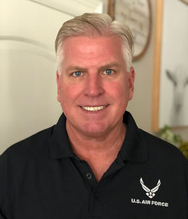
PRESIDENT’S NOTES
Mike Tillema, ARA President
Happy New Year Members of the Air Rescue Association!
I hope this finds you well, warm, healthy, and happy. Welcome to 2026 and the 50th year of the Air Rescue Association…say what? 50 years of recognizing and awarding the world’s best Air Rescue professionals and being associated with so many heroes. What rich history the ARA has and I’m so glad to be part of it. Look for a cool 50th ARA coin later in the year.
A reminder that we worked with the Pentagon and Air Force Personnel Center to change the dates for our Air Rescue Symposiums/Reunions. The new dates are 4-7 Mar 2027 for the 2026 calendar year Rescue awards and futures Symposiums/Reunions will follow in the spring of each year. We will continue to try to line up our event with the AF Rescue Senior Leader conferences that occur about that time, too. Having the event in Sep/Oct continued to be very difficult and this year’s shutdown on Day 1 of the symposium was problematic. We flexed and all was fine as you’ll soon read!
The Reunion in early Oct at the Ft Walton Beach Island Hotel was superb. Some 165 wonderful people of love AF Rescue attended. We were blessed to have so many family members and former Airmen from various crew positions attend. There were smiles and laughter abounding. A bunch of PJs/CROs hanging out with Maintainers who were sipping a cold beverage with Pedro Rescue Helo Association members who were talking with FEs and Gunners was a sight to see. It all seemed to end too soon. I’m so glad and was honored to see and meet many first time Reunion attenders…thank you thank you thank you! Our speakers were phenomenal and flexible as the shutdown made us jump through a few hurdles. Jeff Macrander and Kurt Matthews were exceptional discussing their “Lone Survivor” mission/story. 88-year-old PJ Tommy Miles was unbelievable as he told his H-43 Huskie story when his helo was blown out of the sky as the B-52 blew up underneath him. Hearing Fred Bergold tell the crowd about the last rescue mission in Vietnam in the Huskie was so inspiring. John Mangan was awesome as he described his missions in Afghanistan and Iraq…lessons learned part was quite intriguing, too. Thank you all for saying yes when I asked…just amazing and you all are heroes. A special thanks to the ARA ORCs (old, retired Colonels) and their $3K donation 15+ members gave. That enabled a free Thursday night welcome social, and ARA even put up another $1K so all could continue to enjoy the open bar. Thank you for all your generosity. Thanks again to TOMLF for the very generous donation that really helped curb costs for all who attended.
The Gala night was wonderful. We welcomed in our first class of the ARA Hall of Fame, and yes, we miss you dearly John Flournoy. See their names and pics later. Rick Sheets, the President of the PHRA, wasn’t able to attend as he just had major surgery (healing well BTW). Roger Barre, the Pedro Vice led well, and he and the rest of the Pedros were welcomed as new lifetime members of the ARA. The winners of now four USAF-level Rescue awards were phenomenal. The 57 RQS from Aviano was the squadron of the year. The shutdown didn’t afford them the opportunity to attend but Sarah Lively, the Executive Director of TOMLF, read the citation and a note from the 57th CC, Lt Col Bobby Theologis. The 23rd Wing from Moody showed up in force even during the shutdown with no TDY funds available. Thanks to TOMLF and the financial help you gave some 20 Airmen. The 347th Rescue Group won the Jolly Green Rescue Mission of the Year and the first maintainer of the year, was from Moody…SSgt Justin Hartman, a 130 flying crew chief! His wing commander, Col Sean Hall attended, too, Hartman was a bit nervous! Maj Lucas Duncavage, an AFSOC V-22 pilot from Cannon AFB won the coveted Kight Award. Much more about our winners follow.
I’m currently talking with the leaders of the A-1 Skyraider Association. They will hopefully be joining us as the Pedros did and become lifetime ARA members. Having our Rescue Close Air Support pros as part of our organization will be phenomenal. We know that’s only part of their job, but what a bunch of heroes. From my wife Kim and I, and your ARA Board, Happy New Year. Bless you all and please remember and pray for our deployed personnel who continue to defend the flag.

2025 ARA Reunion and Symposium Photos
Fort Walton Beach, Florida
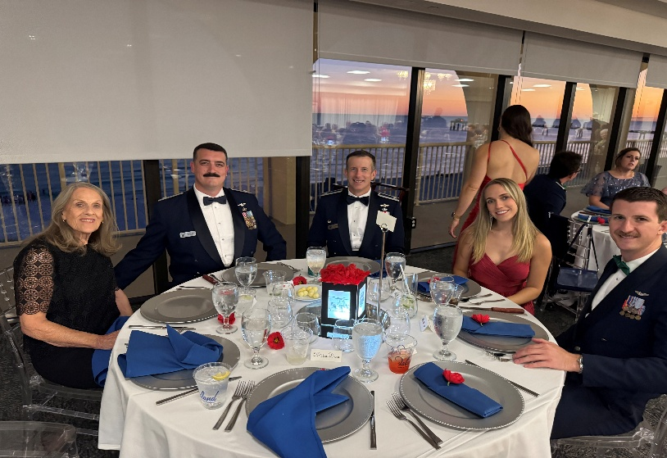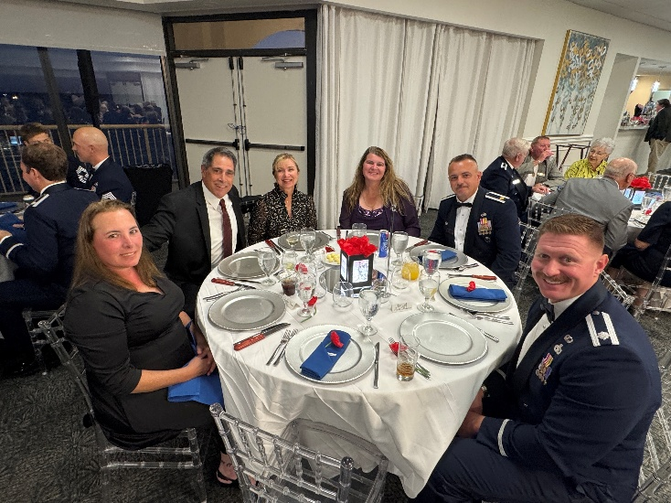
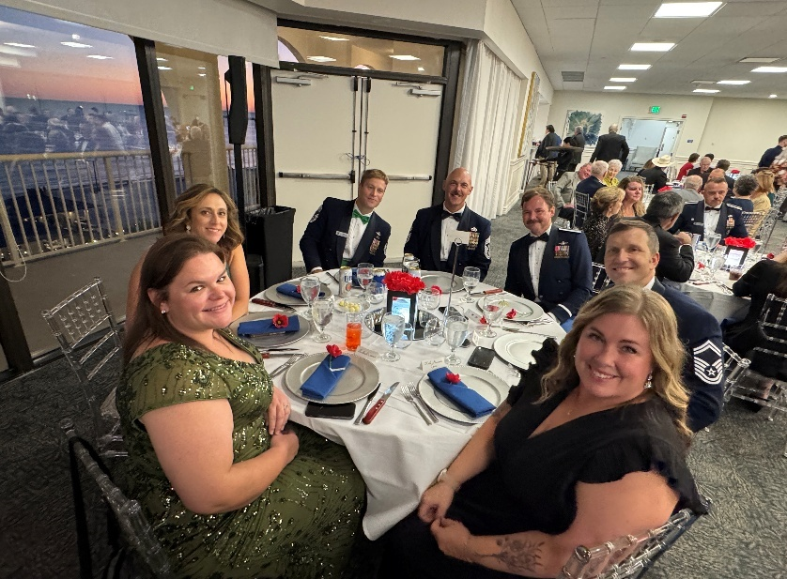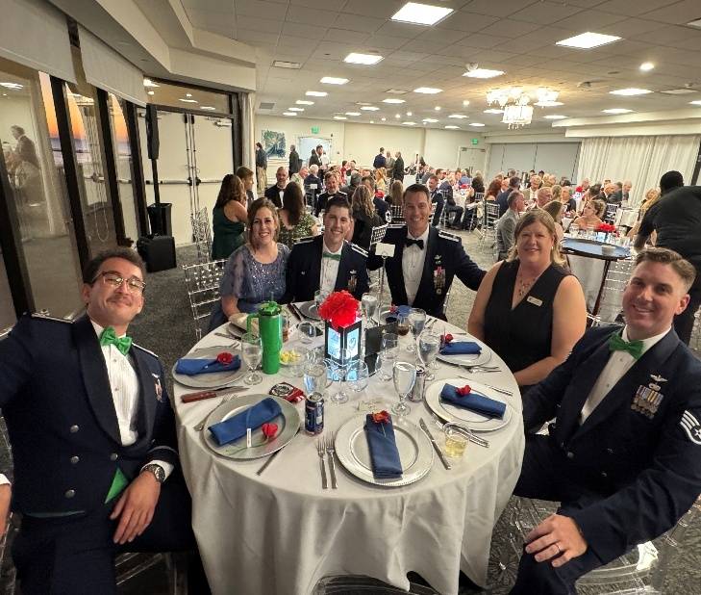
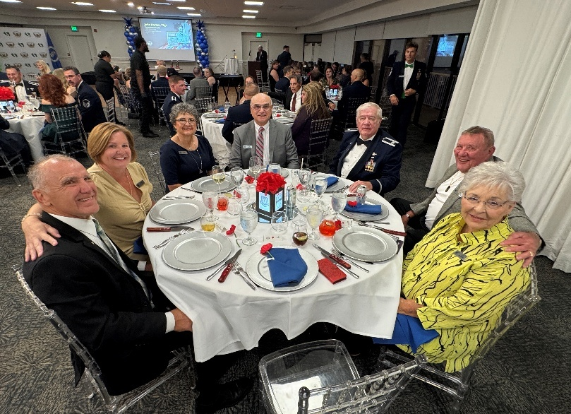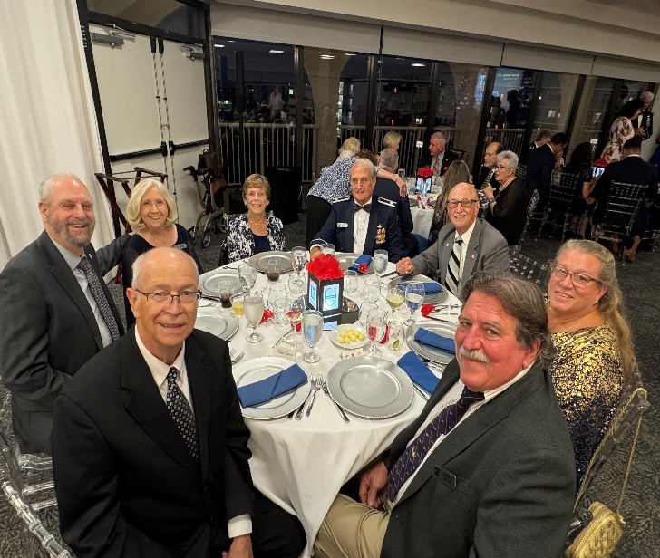
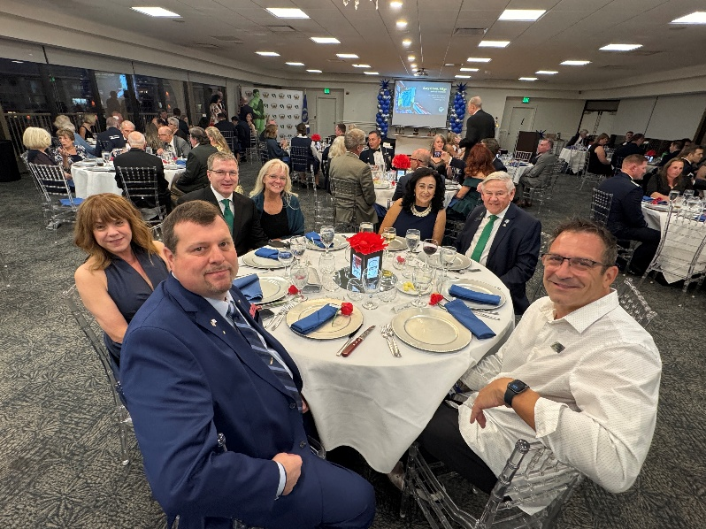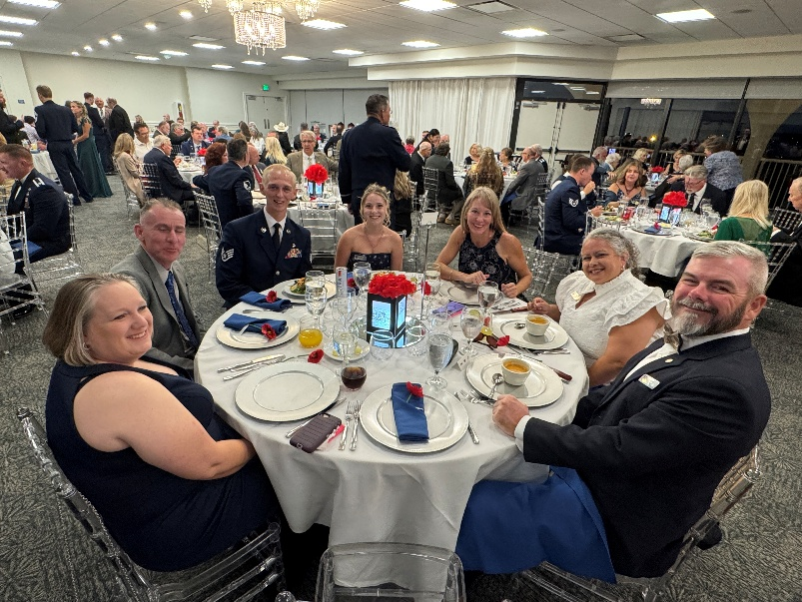
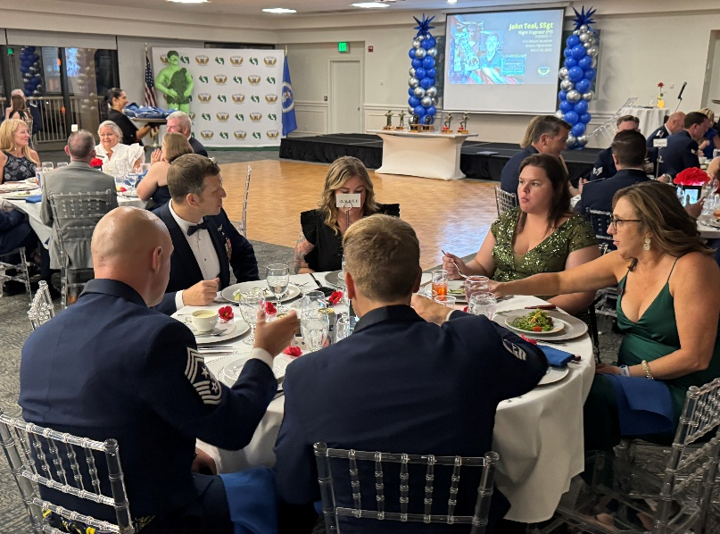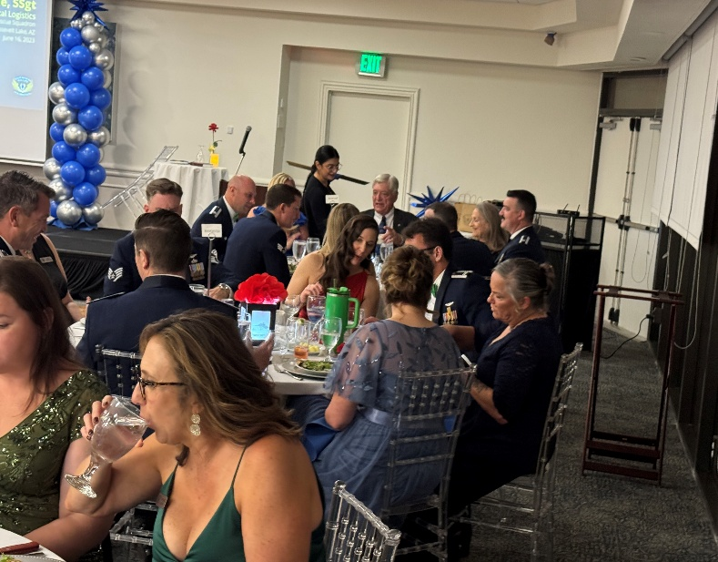
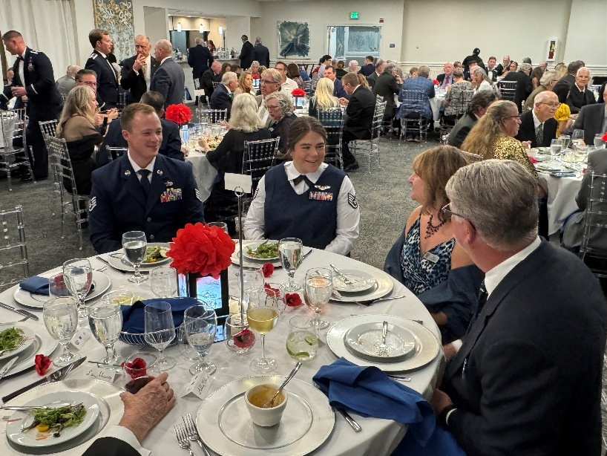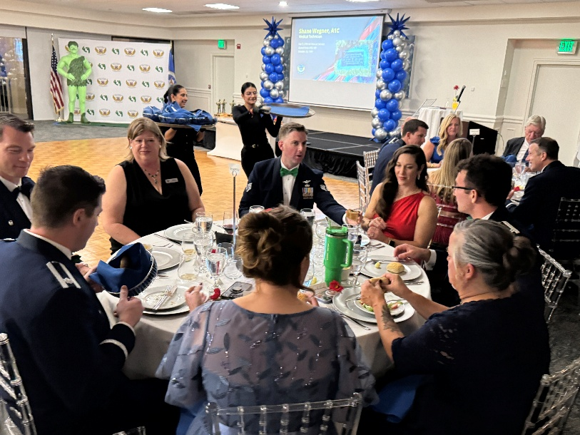

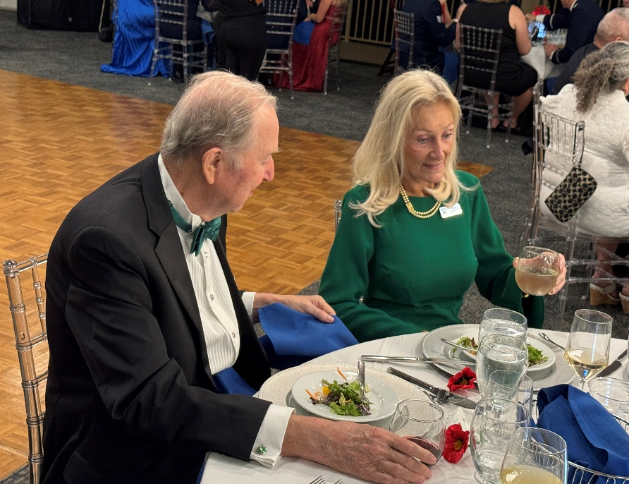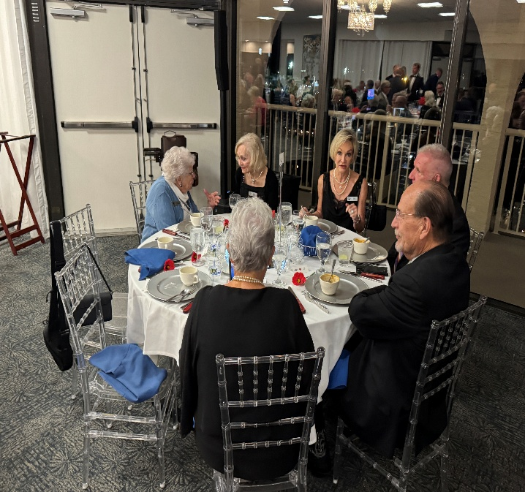
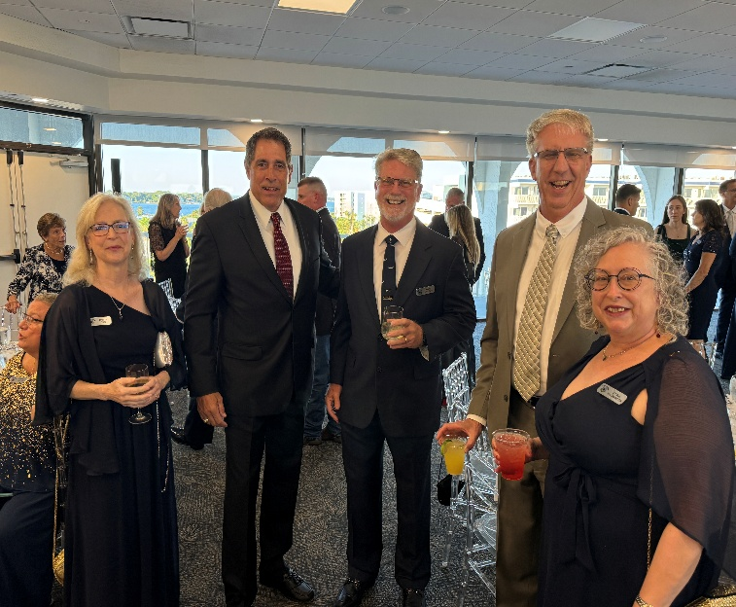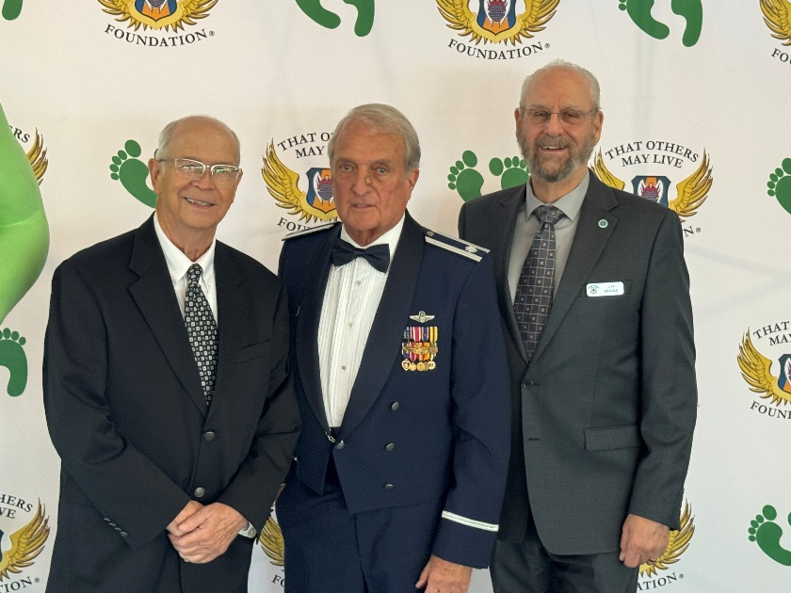
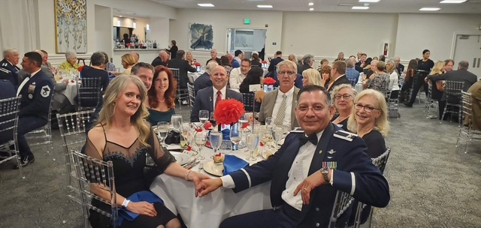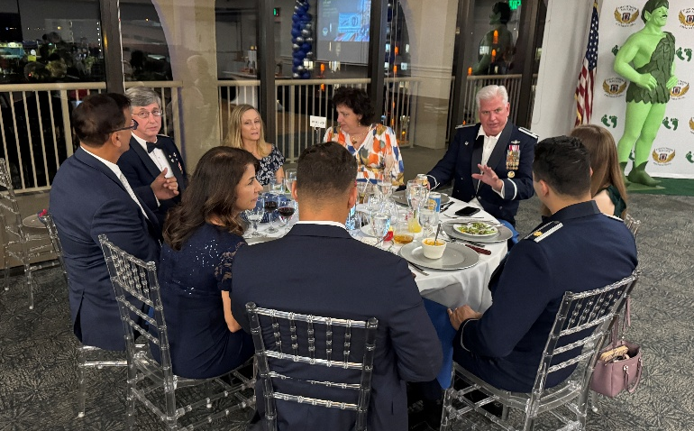

ARA’S Hall of Fame Inaugural Class, Class of 2025
CHARLENE AND JOHN FLOURNOY MARY ELEANOR AND WALT HINES
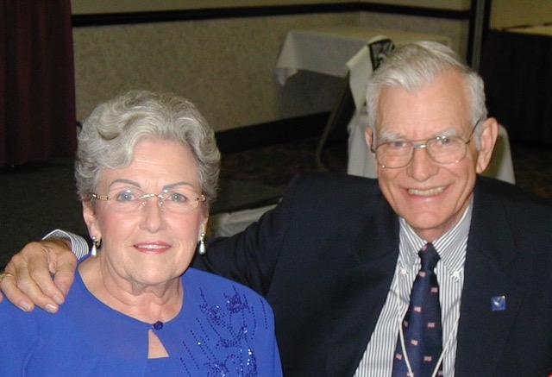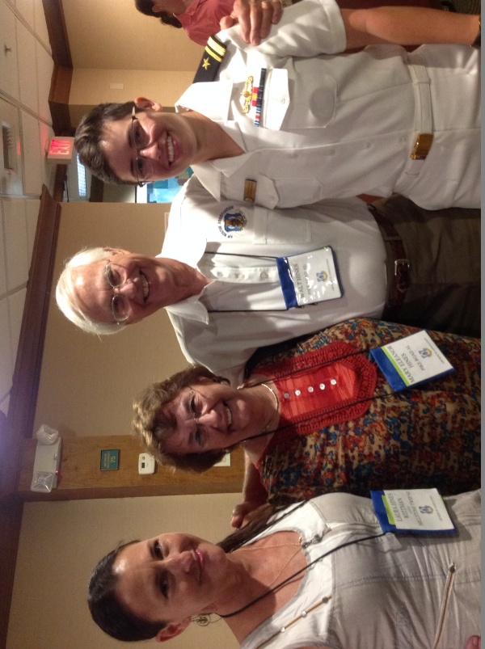
MARY AND BILL SEVERNS SISSY AND ED FITZ
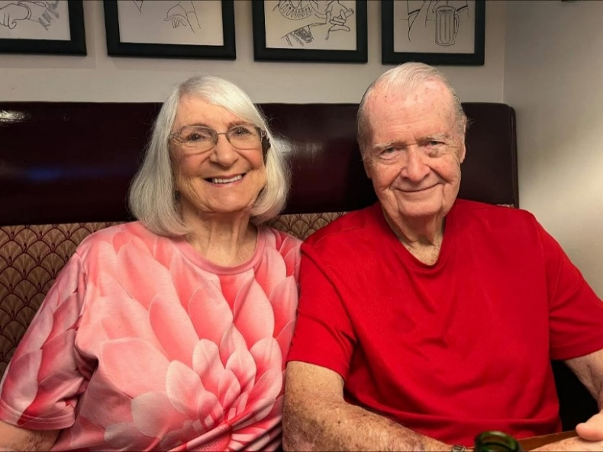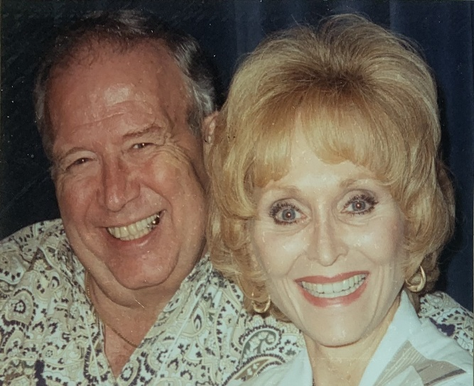
BARBARA AND GRAND GOZA JO AND BARRY KAMHOOT

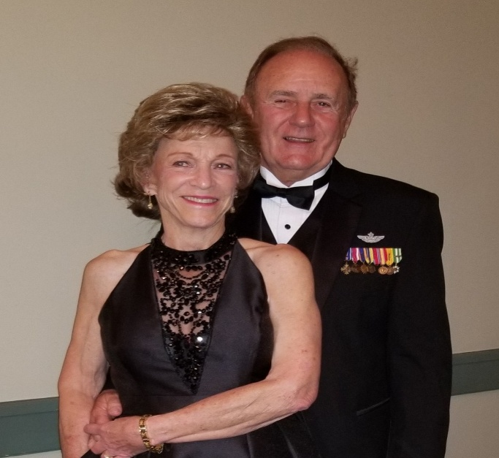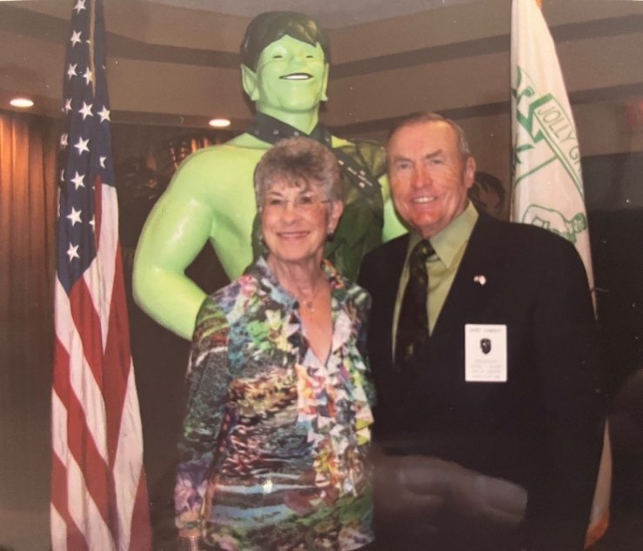

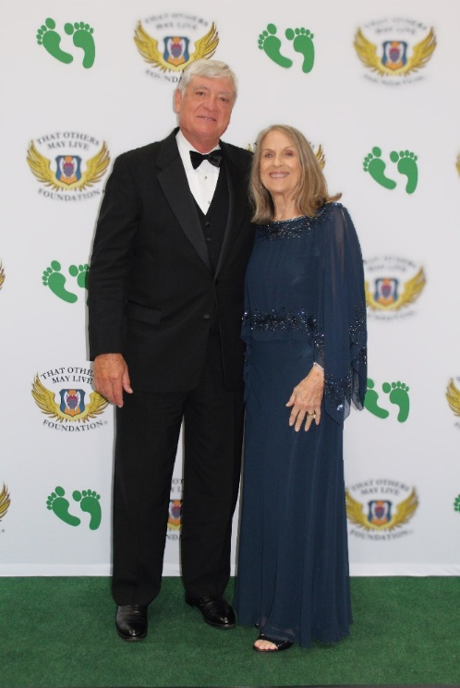
OTHERS SELECTED WERE PEG AND RON GERMAN, AND MARILYN AND FRANK WATKINS

CAROLYN AND KEN PRIBYLA

2025 RESCUE AWARD WINNERS AND CITATIONS
Congratulations to all this year’s award winners!
THE AIR RESCUE ASSOCIATION 2024 RICHARD T. KIGHT AWARD
MAJOR LUCAS T. DUNCAVAGE

Major Lucus T. Duncavage distinguished himself by meritorious achievement as CV-22B Flight Lead, Special Operations Task Unit 020, Special Operations Task Group East Africa, Somalia from 01 April 2025 to 30 June 2025. Major Duncavage led special operations aviators and Guardian Angel operators during a four-hour flight to rescue injured partner forces. Additionally, he led a two-ship formation coordinating three aircraft and a Joint Terminal Attack Controller to execute a landing to a confined landing zone, evacuating two partner forces and two killed-in-action. Furthermore, he enabled four casualty evacuations, resulting in the life-saving recovery of nineteen partner forces, contributing to the stabilization of the Horn of Africa. The distinctive accomplishments of Major Duncavage reflect great credit upon himself and the United States Air Force.

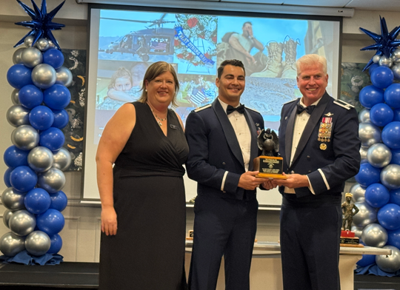

THE AIR FORCE JOLLY GREEN 2025 RESCUE MISSION OF THE YEAR AWARD
JOLLY 41 FLIGHT, VIKING, AND BANDAGE 48 FOR SUPERIOR AIRMENSHIP EPITOMIZING THE MOTTO “THESE THINGS WE DO THAT OTHERS MAY LIVE”

Jolly 41 Flight, Viking, and Bandage 48 distinguished themselves on 7 Feb 2025 while assigned to the 46th, 52nd, and 26th Expeditionary Rescue Squadrons, 332d Air Expeditionary Wing, undisclosed location. On that day, Jolly 41’s flight of two HH-60Ws and Bandage 48’s HC-130 launched on a no-notice casualty evacuation of two independent patients on a nine-hour mission. Through adverse weather, aircraft malfunctions, and a dynamic threat picture Bandage 48 rushed to the first patient’s location while Jolly 41 flight loaded the second patient and proceeded towards the transload location. Onboard the HC-130J, the Viking Team provided critical airway intervention to stabilize their patient until transferring him to higher care. Bandage 48 then returned to the transload location to meet Jolly 41 flight as they navigated blizzard conditions, causing Viking to take extra precautions in protecting a patient with appendicitis. The Jolly, Viking, and Bandage teams efficiently transloaded the patient and Bandage successfully transported them to the appropriate medical facility, ultimately saving both lives. The distinctive accomplishments of Jolly 41 Flight, Guardian Angel team Viking, and Bandage 48 reflect credit upon themselves and the United States Air Force.
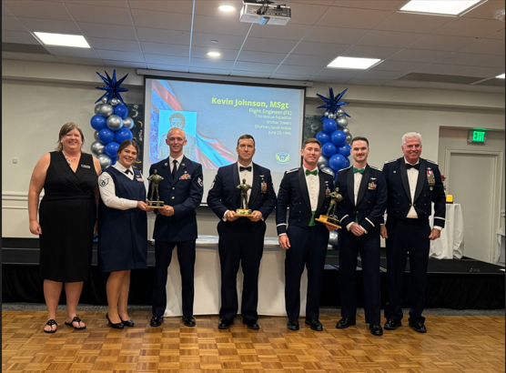

AIR FORCE RESCUE SQUADRON OF THE YEAR
57TH RESCUE SQUADRON

57th Rescue Squadron, 31st Operations Group, 31st Fighter Wing, Aviano Air Base, Italy, 1 July 2024 to 30 June 2025. During this period, the 57th operationalized the Air Force rescue's first organic drone program and slashed legacy fix/find search time by 3000% validating rescue's small drone ISR, kill chain capabilities, and published stand-up procedures to entire Guardian Angel enterprise. The squadron directed two casualty evacuations of Danab Partner Forces, including the largest AF-tasked mass casualty event in East Africa history, executing life-saving interventions & transporting 28 critically wounded to advanced medical care. Finally, the 57th Rescue Squadron partnered with the Swiss Air Rescue team to execute 18 real-world alpine rescue missions, saving multiple civilians. The distinctive accomplishments of the 57th reflect credit upon itself and the United States Air Force.
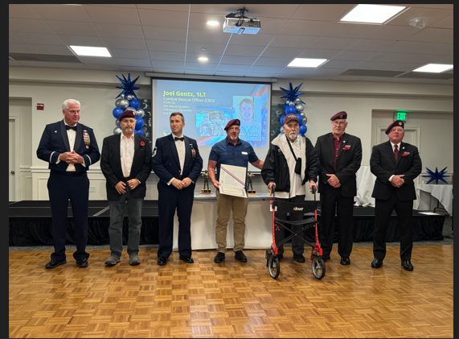
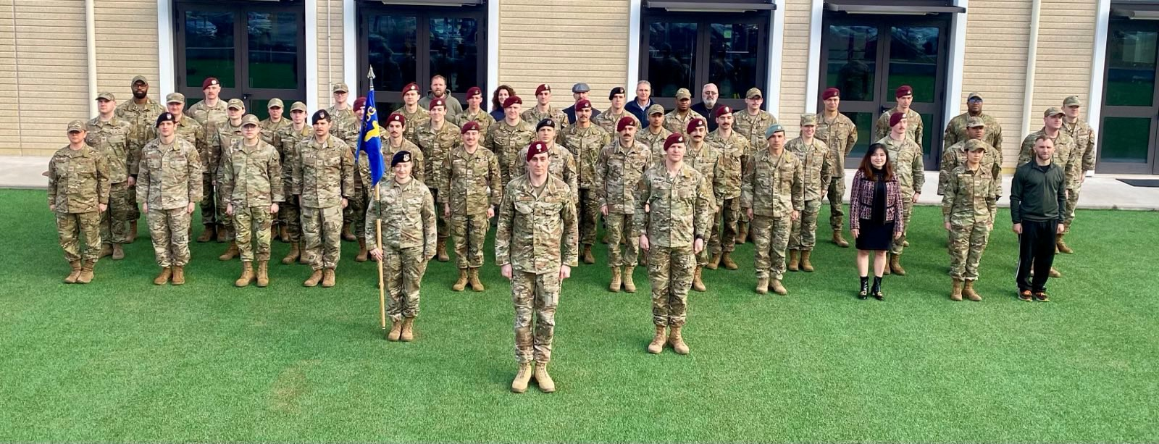

THE 2025 AIR FORCE RESCUE MAINTAINER OF THE YEAR
STAFF SERGEANT DYLIN E. HARTMAN
Staff Sergeant Dylin E. Hartman distinguished himself as C-130J Flying Crew Chief, 71st Rescue Generation Squadron, 23rd Maintenance Group, 23rd Wing, Moody AFB, Georgia from 1 July 2024 to 30 Jun 2025. SSgt Hartman inspired lethality, agility, & resilience through 4.4K alert hours and flying 20 combat sorties moving 767 personnel and 589K pounds of cargo. These flights included five US Navy aerial refueling missions of important unmanned aircraft systems. Sergeant Hartman supported two international joint task force missions, deploying four HC-130Js, flying 24 sorties with 25 joint inter-agency partners resulting in 23 arrests, the seizure of 4.6K kg of narcotics, & firearms valued at $193M. He was the lead expediter during a seven-month deployment for Operation INHERENT RESOLVE executing 245 missions and 625 flight hours. Sergeant Hartman solidified Hurricane Helene evacuation efforts by generating seven HC-130Js, arranging safe haven of $2.3M in equipment. The distinctive accomplishments of Staff Sergeant Hartman reflect great credit upon himself and the United States Air Force.
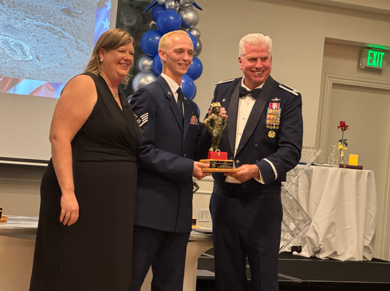

Pedros in action!
Photos by Neil McCutchan Feb – Apr 1965

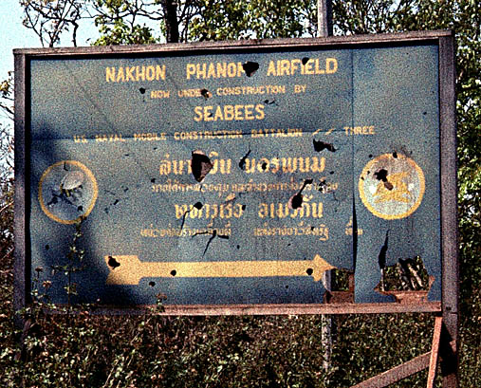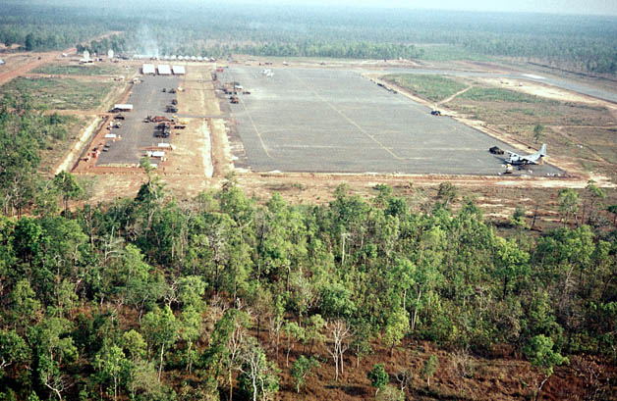
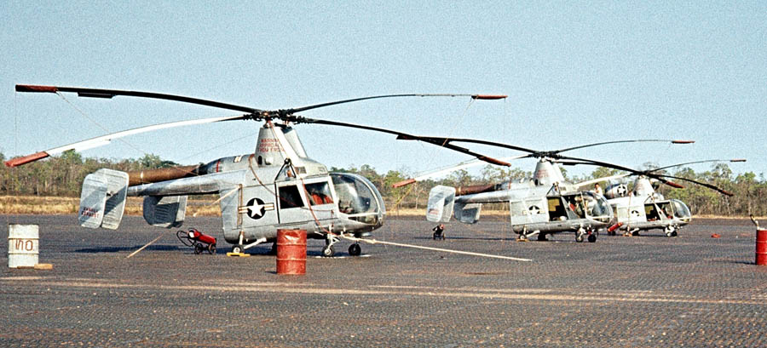

The Four Faces of the PRHA Monument
Great job Pedro’s as four monuments have been built and placed at Gunter AFB, the Air Force Academy, Lackland AFB, and at Wright Patterson AFB. Beautiful Tribute! 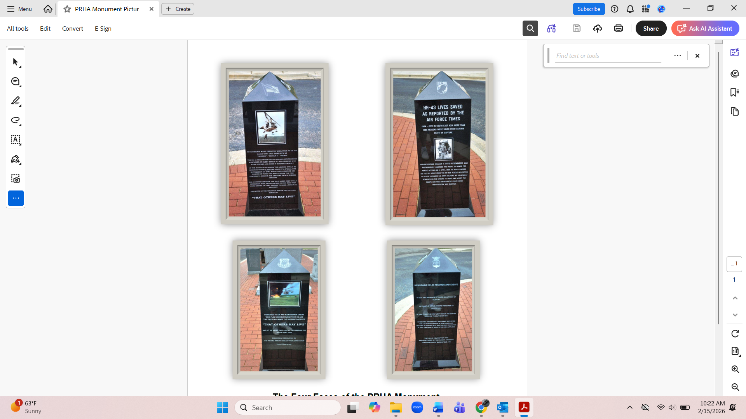

PARARESCUE NEWS – Please visit https://conta.cc/4r5m2kO
Event Honoring Medal of Honor Recipient Staff Sergeant William H. Pitsenbarger
On April 11, 2026, the Air & Space Forces (AFA) Wright Memorial Chapter (WMC) will proudly join the City of Piqua and community partners in honoring the 60th anniversary of the heroic sacrifice of Airman 1st Class William H. Pitsenbarger, a true American hero and Medal of Honor recipient. Pitsenbarger grew up in Piqua, Ohio, and lies in rest in nearby Covington. This commemorative weekend will be part of the City of Piqua’s “America 250” celebrations, recognizing 250 years of American independence.
Airman 1st Class William H. Pitsenbarger served as a Pararescueman with the U.S. Air Force in the 38th Rescue Squadron during the Vietnam War. On April 11, 1966, while rescuing wounded soldiers under intense enemy fire near Cam My, Vietnam, he was mortally wounded and made the ultimate sacrifice. For his actions that saved the lives of 60 soldiers, he received the Air Force Cross. The Air Force Cross was later upgraded to the Medal of Honor, the nation’s highest military decoration for valor, and awarded to his family by then Secretary of the Air Force F Whitten Peters. He was posthumously promoted to Staff Sergeant during this ceremony at the National Museum of the United States Air Force.
This event is open to the public - all are invited. Several survivors whose lives were saved by A1C Pitsenbarger that day plan to attend. At least one HH-43 Huskie crew member from the sister aircraft will attend. Please spread the word to your HH-43 Huskie friends and others. Thank you.

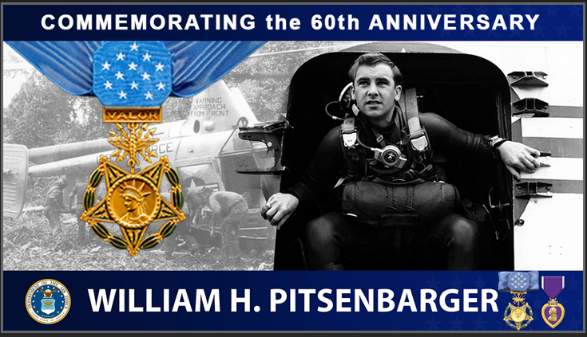

THAT OTHERS MAY LIVE FOUNDATION UPDATES
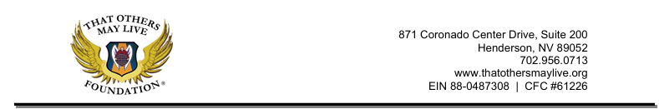
February 2026
Hello ARA Friends and Family,
As we enter the new year, there is renewed energy across our Rescue community. At That Others May Live Foundation (TOMLF), that momentum shows in record scholarship applications, new events that strengthen connection, and thoughtful program updates to better serve our families.
This community is built on shared experience, deep respect, and a commitment that extends beyond the mission. Our focus remains steady: caring for the families who carry the legacy forward.
Thank you for staying connected and continuing to live That Others May Live in action as we move confidently into the year ahead.
Jolly Green Merit Scholarship
TOMLF is proud to announce that the Jolly Green Merit Scholarship (JGMS) is officially open for the 2026 application cycle—and off to a record-breaking start.
Since opening on January 30, we have already received 20 applications, marking one of the strongest early responses in the program’s history. This momentum reflects the excellence, leadership, and service-minded character of the next generation of Rescue families.
JGMS honors academic achievement, resilience, leadership, and commitment to community—investing in students who embody the spirit of That Others May Live. Applications remain open until April 30th, and we look forward to reviewing an exceptional field of candidates in the months ahead.
Link to application: https://www.jotform.com/form/251237197272156
Upcoming Engagements
TOMLF Golf Classic – Operation Saving Par
Saturday, March 14, 2026 (Tucson, AZ)
Join us for a day of camaraderie, competition, and community impact in support of
Rescue families.
Register here: https://givebutter.com/c/OperationSavingPar
Toasting the Bold 2026 – California
Friday, April 10 – Gala (Santa Ynez, CA)
An elegant and inspiring evening celebrating the courage, service, and enduring legacy of U.S. Air Force Rescue families. The night will feature special guest speakers including film director and producer Todd Robinson of The Last Full Measure and Col. Thomas Keegan, 129th Rescue Wing Commander, Moffett Airfield, California Air National Guard.
This year, the program will solemnly honor the tragedy of King 56, reflecting on the sacrifice, the lives forever changed, and the enduring strength of the Rescue community in the face of profound loss.
Reserve your seat or table: https://givebutter.com/c/TTBCA26
Saturday, April 11 – Music Fest (Solvang, CA)
A high-energy community celebration featuring live music and mission-driven impact. This inaugural Music Fest lineup includes performances by Jackson Gillies, Carly Jackson, Shawn Jones, Christian Lopez, Lois Mahalia, and Stephen Styles—bringing an unforgettable mix of sound, spirit, and community to the stage. Tickets on sale soon!
As 2026 unfolds, TOMLF remains steadfast in expanding both our reach and our impact across the Rescue community. With strengthened partnerships, new events on the horizon, and thoughtful program enhancements underway, we are positioned for meaningful growth in the year ahead.
Thank you for your continued trust, engagement, and commitment to the mission. Together, we honor the legacy, care for our own, and move confidently toward all that lies ahead.
With gratitude and respect,
Sarah Lively
Executive Director

Supporting USAF Rescue Warriors and Families since 2002

RESCUE MAINTENANCE IN AFGHANISTAN
Helicopters, Horns and Chutzpah, by CMSgt (Ret) Tony Ray
Ask any airmen who has shared a connection to our benevolently lethal community, and they should be capable of reciting a tale or two about rescue missions in the analogues of campaigns spanning generations and the globe. Exploits of the rescue community, be purely genuine or slightly embellished, are the stories that make award citations and AFN commercials great.
But not all great rescue stories are born from LZ, in a hot and heavy OGE pulling a team. Sometimes epic stories aren’t steamed with bravado, but are chalked full of the mischievous and sometimes irreverent antics that can only be found within the ranks of the feral rescue maintainer. And it should be appreciated when a maintainer is willing to spend time, use words, and share such an account for the masses, you need to buckle in because it’s going to be good.
For the reader with little exposure to maintenance culture, one should understand maintainers often are not afforded a level of comity as their aircrew contemporaries. For example, while bedding down at a deployed location, leadership from a host wing, or a co-located fixed wing unit may come by for an immersion visit. Nothing more than an opportunity to say hello and offer best wishes and assistance for a successful tour. In maintenance, oftentimes the immersion visit is by the curious, hover-impaired logistics professional who’ve come to see the rumored “cowboy” maintainers, and “lay down the law” of expectations from a fixed wing Air Force. A stark contrast.
With the atmospheres in the maintenance trenches defined, I can share with you the events that may or may not have unfolded before my own eyes late on a December evening at Bagram Air Base in 2009. The names of the fixed wing maintenance leaders have been lost to time, but after reading this, the name of the helicopter crew chief will become infamous.
I was a Pro-Super attached to the 33d out of Kadena, and the lead maintainer on the trip. We had been in-country since early August, and like any other rescue tour, we experienced the highs and lows. We had mundane days that never seemed to end, and alert periods when hours flew past like seconds. Proudly, I had an amazing maintenance crew that rose to each challenge they faced. Despite the impressive record, we still had to entertain the constant inquiries from our maintenance leaders who didn’t speak rescue. The night our relief was inbound from homestation was no different, but way more memorable.
We began our 12-hour shift at 1500L. When I arrived the ATOC schedule showed our relief would be arriving on two C-17s, with pax and pallets to receive, and one helicopter to download around midnight. As luck would have it, this particular day fell on our alert rotation in which we were “first up” in response to any significant event in RC-East.
Early in the shift I had to brief the maintenance group about our plan to welcome our replacements, marshal cargo, download and tow an aircraft across the base, and manage the alert. No big deal, just another night of herding cats.
During the brief I had to dance around a barrage of “what if” questions. What happens if the replacements land early? What happens if we take in-direct fire? What happens if the weather is inclement? What happens if you have to launch on a mission? The questions were endless, and so was my ability to juke them all. I felt like I answered them all satisfactorily, until they all happened at once.
Around 2230 I received the first call for our in-bound replacements, 45 minutes out. Plenty of time to gather our team and head over.........REDCON ALPHA, REDCON ALPHA, REDCON ALPHA broke squelch on the net and now the show was on. Within seconds crews ran to the aircraft to make the launch. Two hovers in less than 11 minutes was the goal from notification, and just as in the weeks and months before, we pulled it off without a hitch. Another manifestation of “These things we do that others may live”.......RESCUE!
The Pedro flight departed and our attention returned to the inbound C-17s. Within minutes the teams who needed to meet the inbounds departed and I had a small crew left to recover the Pedro flight.
Within minutes, the maintenance group deputy and superintendent frantically made their way to the ramp to revisit all the questions from earlier in the evening. Who was launching aircraft? Who was downloading the H-60 and towing it across? Are they qualified, blah, blah, blah. I’d become numb to the never ending questions, but never enjoyed it until this evening. After about 15 minutes of standing in my office with the group leadership, revisiting all our plans for the evening, it seemed I finally began to satiate their concerns. That was until the radio erupted “Pedro flight 5 mike out” and the “C-17s on the ramp”.
The calm quickly faded, my patience, low-level light was flickering and just as the line of questions was about to send me back into the depths of another inquisition. Now there are often stories from the AOR that just seem unfathomable, but remember, I’m a dirty maintainer taking the time to write it, it happened. Just as the intense rapid-fire questions began again, our resident goof ball, SSgt. Justin Spritzer burst into the room.
Now it might seem superfluous for me to mention SSgt Spritzer is Jewish. But when I tie it together with the fact that when he entered the room he was wearing his headset and reflective vest, over the top of an anatomically correct, spotted milk-cow costume. Horns, udders, cow bell, and an oversized Star of David around his neck that would make Flavor-Flav jealous.
“Don’t worry about the helicopters Sgt Ray, I got em!” and in a flash, he was back out the door. It was utterly amazing.
I looked back at the bewildered maintenance leaders who had no clue what they had just witnessed. Their only remaining question was “Who the hell was that?”.
Nonchalantly I replied, “The cow-jew? That is SSgt Spritzer, he is going to recover the helicopters. I’d love to stay and chat, but I better go there with him in case he needs me. Everyone else is recovering the C-17s”.
I grabbed my radio, headset and battle rattle and walked out and never looked back.

KING (C-130) SOUTHEAST ASIA COMBAT RESCUE
Southeast Asia Combat Rescue by Col (Ret) Bill Goodwin
Pilot training was at Webb AFB, Texas. Graduating in 1969, I was assigned to Elmendorf AFB, Alaska and the 71st Aerospace Rescue and Recovery Squadron (ARRS) to fly HC-130 combat rescue aircraft for two years. There could not have been a better assignment for a new copilot – low level contour search missions at 1,000 feet, medivac missions into austere Air Force Radar sites and civilian airfields, air refueling H-3 helicopters, and averaging 50 flying hours each month. By the time my tour finished in 1972, I had been upgraded to aircraft commander. I volunteered for reassignment to continue to fly combat rescue missions in South Vietnam. My orders came through assigning me to the 39th ARRS at Cam Rahn Bay South Vietnam.

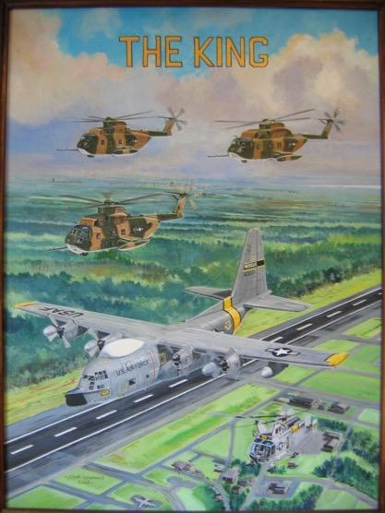
Enroute to the 39th, I attended water survival training at Homestead AFB, FL and then Jungle Survival training at Clark AB. While I was at Clark, I was informed that the SEA combat rescue mission had been moved from Cam Rahn Bay to Korat Royal Thai Air Base. I arrived at Korat and found that the unit would be the 56th ARRS. Check out took a couple weeks and I was on the normal flight schedule rotation. Crews were normally assigned to fly the King 21 mission with an 0-dark thirty departure and fly an orbit over northern Loas until relieved around noon by the King 22 mission. King 22 remained on orbit until fighter operations were finished that afternoon. The rotation would start with a King 21 mission on the first day followed by a King 22 mission the second day. On the third day the crew would assume rescue alert as King 27. The fourth day found the crew on a pseudo alert called King 26. I say “pseudo” because, by regulation, there were no “pseudo” alerts. Nobody was willing to tell the commander that this was not authorized.

On 26 August 1972, I was flying the King 21 mission. We were on orbit over northern Loas as fighter packages were scheduled to go north that day. It was during that mission that Motion A2, an F-4 was shot down over North Vietnam while egressing. Motion A2 Bravo, the back seater, came up on radio to the overhead fighter aircraft to say that he was on the ground. While coordinating with the overhead fighter aircraft to get an exact position for Motion A2 Bravo, we immediately called for the scramble of Jolly 62 and 63, the HH-53 rescue alert birds at Nakhon Phanom (NKP). They were escorted by two A1E Sandy aircraft. As the 53s flew north, we joined up with them to refuel them with the needed fuel to continue to the rescue pickup point. Given the last known position of Motion A2 Bravo, the Sandies and Jollies proceeded to make the pickup. King 27 was alerted and launched to provide any additional refueling needs.

The Sandies and Jollies contacted Bravo, authenticated that Bravo was indeed Bravo, and initiated the pickup. Unfortunately, enemy personnel were waiting for Jolly 62 to hover over the survivor for the pickup and began to fire upon the helicopter. Jolly 62 received severe battle damage and without being able to rescue Bravo, was able to egress the area. Jolly 62 immediately called us for fuel. The ground fire had penetrated the auxiliary fuel tanks which required air pressure to transfer fuel to the main fuel tank. The holes in the tanks prevented this transfer. To reduce weight, Jolly 62 jettisoned the tanks. 62 also stated that the engines had been hit and the rotor blades had also sustained damage. This would require us to slow as much as possible. As we initiated the join up for refueling, I slowed the HC-130 to the charted minimum operating speed (MOS), approximately 97 knots. As we passed under Jolly 62, I cleared him to the hose. However, as Jolly 62 was preparing to refuel, the refueling probe extended and fell off the helicopter. Our initial intent was to refuel Jolly 62 on the hose all the way back to NKP, but that was no longer an option. To add insult to injury, Jolly 62 did not have enough power to draft behind us at our MOS.

Our navigator immediately went out on guard frequency asking any Air America pilot to come up on our rescue frequency. An Air America pilot responded and when asked for a suitable place to land Jolly 62, he informed us that Lima Site 32 was the closest. As the navigator was coordinating for a landing site, I coordinated with the crew that I planned slow the aircraft 5 knots below MOS to allow Jolly 62 to draft behind us and give him a little more airtime. If any crew member saw any reason to stop during this procedure, they were to speak up. Coming in below Jolly 62, I carefully slowed the aircraft to 92 knots. The 130 remained stable and even allowed for up to 5 degrees of bank for course corrections. The great part was that Jolly 62 was able to draft behind us and extend his flyable distance. We got Jolly 62 safely to Lima Site 32. Jolly 63 had stayed behind at the pickup point and was able to retrieve Motion A2 Bravo and headed south. Jolly 63 then flew to Lima Site 32 and took the Jolly 62 crew less the 62 and 63 PJs to NKP. The PJs stayed with the Jolly 62 aircraft until Engines, rotor blades, and other required parts were flown in to repair Jolly 63 for a return flight to NKP. We returned to Korat while King 27 joined up with Jolly 63 and provided the fuel needed for the return flight to NKP.

Little did I think about this until around 1982 when I was assigned to the 55 ARRS at Eglin AFB, FL. HQ MAC directed that all aircrews conduct approach to stall training under the direction of an instructor/flight examiner pilot. As an instructor pilot, I followed the written guidance and then, with total crew agreement, demonstrated to each pilot that the HC-130, while configured for air refueling, could safely fly 5 knots below the published minimum operating speed. Once at the demonstration airspeed, each pilot saw that they could make 5 degree turns effectively.

Once again, I didn’t think about this until the procedure possibly saved an HH-3, crew, and medivac patient. An HH-3 from one of the east coast bases was tasked to fly to a ship in the Atlantic to pickup a patient for transfer to an appropriate medical facility. One of our HC-130s was tasked to provide the necessary refueling assistance. The HH-3 actually ended up going to a second ship for a pickup and during the recovery phase lost power in one engine. When the HC-130 attempted to join up for refueling, the HH-3 was not able to keep up. With the HC-130 slowing to MOS, the HH-3 still could not stay in the refueling range. The HC-130 pilot then briefed the crew that he was going to slow 5 knots below MOS and see if the HH-3 could be refueled as necessary. As it turned out the HH-3 was then able to maintain the refueling position and took small amounts of fuel as necessary to keep the weight down. This procedure was maintained for 3 hours at less than 1,000 feet above the ocean until the HH-3 was able to land at a suitable field.

Divine providence places us in situations that, at the time, don’t necessarily make sense. However, my experience in Southeast Asia, followed by the HQ MAC directive to train aircrews in stall recognition and my initiative to carry that training one step further, resulted in the safe recovery of an HH-3, its crew, and patients over the Atlantic Ocean.

A-1 SKYRAIDER STORIES
Lady Ace Rescue - July 1972, by Lt Gen (Ret) Tex Brown
On the midday of 11 July 1972, I then 1Lt Tex Brown was sitting Sandy alert at DaNang AB, South Viet Nam, with my wingman, Capt. Lee Mazzarella. We were A-1 Skyraider pilots deployed from NKP RTAFB, Thailand to DaNang to fly search and rescue (SAR) for any downed American flight crews. The morning had been uneventful but at around 1400 the claxon went off indicating an airplane had been shot down and Americans needed rescue. We scrambled to our A-1H Skyraiders and took off with approximate coordinates of the downed aircraft. Lady Ace was the call sign, and it was a US Marine CH-46 helicopter near the area of Quang Tri, SVN. Within 45 minutes we were over the survivors and had radio contact with the crew which consisted of 6 marines who had autorotated into a soccer field to the southeast side of the city of Quang Tri. They were together and in pretty good shape except for one crewman who was severely burned and injured. We authenticated them and then moved radio frequencies to a backup Guard channel. As Sandy Low lead I commenced making dry runs over and near the survivors to try and determine the surface to air threat and to silence any threat to the crew and or a rescue Jolly Green helicopter.

The Jolly's had launched from DaNang too and were holding feet wet safely over the Gulf of Tonkin just 10-15 miles from the search area. The troll for gunfire takes a while and is only done when in a SAR situation. During the low level passes I received quite a bit or small arms fire and on 2 occasions had SA-7 Strella surface to air missiles shot at me. Fortunately, my wingman, Pizzaman, saw the launches and called a break turn for me which gave me separation from the inbound missiles. Both times they were near misses but unsettling as the SA-7 would not miss a helicopter were it in the area. In fact, it is likely a Strella missile had shot down our Marine helicopter. Over 2 hours of trolling and neutralizing a few threats

I determined the area was still not safe enough for a big Jolly Green and we were beginning to lose our daylight as nightfall was closing in on our possible recovery. Suddenly a radio call from fellow Americans came over our frequency and it was a US Army helicopter team that worked the area we were in. The team leader told us they were a 6 ship of 2 scout Loaches, 2 Huey Slicks and 2 Cobra gunships. They fly together and were close by as this was their Forward Operating Area. They had been monitoring our progress and decided it was time to step in and help. I described the actual location of the survivors and lead Army pilot felt confident they could get to the Marine team.

At approximately 1730 (just 20 minutes before sunset) the 6 Army helicopters and our 2 AF Skyraiders met at an Initial Point (IP) that was 10 miles south of the survivors. The Army team uses the Loaches to fly lead, then the 2 Huey Slicks are next, and the 2 Cobras protect the rear. They were all at max speed and flying up a dry riverbed at 50 feet (on the deck), The 2 Skyraiders flew a weave pattern to stay near the Army team but at 1000 feet above them. The helicopter team was flying lights out while the Skyraiders went full lights on, thus drawing whatever ground fire (almost all small arms) that existed.

The survivors popped smoke as the Army choppers drew near and the Hueys went inro the soccer field and quickly the 6 survivors were loaded up as the Cobras and Skyraiders went into a daisy chain over the rescue area. Quickly after loading up, the Scouts led the team followed by the Hueys and then the Cobras back south down the same dry riverbed to the former IP and safe area. Once clear of threats the Army Hueys flew the rescued Marines to a nearby US Navy hospital ship that was in the gulf. The other Army team RTB'd to their Forward Operating Base and the two Skyraiders rejoined to fly back to DaNang. My wingman was pretty clean but upon inspection my old bird was full of holes (over 230) and the engine was running rough. My left gear was a bit shot up too so landing at DaNang was a bit dicey. We decided to land Mazz first in case my aircraft closed the runway.

Now it was dark as Sandy 8 easily landed and I, Sandy 7, followed as my old bird held together enough to get on the runway but the left gear semi-collapsed and I ended up stopping on a taxi way to the left of the runway. Upon final inspection my aircraft had 2 cylinders shot up (it has 18) and multiple hydraulic leaks and over 230 holes. A testament to the old piston driven WWII vintage aircraft. As we flew back to base the overall command and Control authority was Crown and they declared this successful rescue was one of the most fully Joint efforts of the Southeast Asia war. USAF Skyraiders overseeing and leading the rescue of US Marines by the US Army and lifesaving care given by the US Navy. Just another day in the life of a 1Lt Skyraider pilot in the Viet Nam war.

After the fact, the 2 Skyraider pilots as well as the Army Huey pilots were awarded Silver Stars!
Army Helicopter Crews included the following crewmembers: 1Lt Pete Holmberg, 1Lt Frank Walker, Capt. Fred Ledfors, CW2 Chuck O'Connell, Rank UKN Russ Miller, Sgt Randy Baisden, Sgt Joe Beck and Sgt Buddy Ring.

RESCUE STORIES OF TODAY
Rescue Airmen save man off coast of Baja California, Mexico, originally published Feb 11, 2026, by 2Lt Grace Brandt, 355th Wing
https://www.acc.af.mil/News/Article-Display/Article/4403369/rescue-airmen-save-man-off-coast-of-baja-california-mexico/
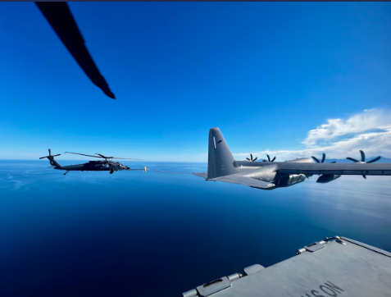
Less than two hours after the 563rd Rescue Group received the first mission brief about a man in need of medical assistance on a tanker vessel off the coast of Baja California, Mexico, on Feb. 5, 2026, the entire team was already flying out of Davis-Monthan Air Force Base to assist.
It would be a difficult mission. The patient, a 19-year-old Greek man, was having medical concerns that had left him paralyzed, increasing the challenge of a water rescue. The distance across open water was almost 400 miles, which would require several air-to-air refueling maneuvers. Pararescuemen would need to hoist down onto the moving vessel and render care. The team would have to coordinate a landing in Mexico to ensure higher-level medical care.
But for the 355th Wing, operating out of Davis-Monthan Air Force Base, Arizona, these weren’t roadblocks—just challenges to overcome.
Instead, Airmen across the base pulled together to mission plan, develop weather forecasts, prepare life support equipment, stage radios, product flight authorizations, fuel aircraft and generate a rescue team. Within seven hours of the original distress call, the 563rd Rescue Group was sending a team of eight aircrew, six pararescuemen and a flying crew chief aboard two HH-60W helicopters and one HC-130J aircraft to Mexico.
“It was a very compressed timeline from [receiving the mission] to launching it,” said 79th Rescue Squadron pilot Maj. Zachary Eberl, who commanded the HC-130 that enabled air-to-air refueling for the mission.
Eberl added that coordination and support across multiple offices was crucial for this mission, since it was taking place over the water outside of Mexico and would require a landing in foreign territory. Despite having multiple aircraft forward deployed for real-world operations and exercises across the globe, the 55th Rescue Generation Squadron and 79th Rescue Generation Squadron were able to generate the aircraft necessary to accomplish the rescue.
“All the support elements were in play to generate those aircraft that experienced aircrew then utilized to do this very long, over-water rescue,” Eberl said. “Additionally, there was a lot of maintenance support that went into having the three aircraft ready to go when we needed them in the morning.”
Airmen from the 55th Rescue Squadron and 563rd Operations Support Squadron made up the air crews on the HH-60W helicopters, while one HC-130J crew consisted of Airmen from the 79th Rescue Squadron and another, contingency aircraft later took off with Airmen from the 418th Test and Evaluation Squadron. Pararescuemen from the 48th Rescue Squadron and Lt. Col. Jeffrey Budis, a pilot instructor assigned to Air Forces Southern, rounded out the team.
To reach the vessel where the patient was located, the search and rescue team flew 17 hours in two days. The nine-hour trip out was more intensive, with four air-to-air refueling operations before the aircraft arrived at the tanker vessel. As the helicopters hovered in midair, pararescue hoisted down onto the moving tanker to retrieve the patient. They rendered in-flight medical care as they transported him to a nearby hospital in Cabo San Lucas, Mexico.
Almost exactly one day later, the team had already returned to Davis-Monthan.
According to 355th Wing Commander U.S. Air Force Col. Jose Cabrera, the successful rescue mission was only made possible through the collective efforts of the entire Davis-Monthan team.
“The mission brought together Airmen from around our wing,” Cabrera said. “Ultimately, their teamwork and effort saved the life of a 19-year-old, who now gets to see his family and friends again. I’m extremely proud of the entire team for living up to the Air Force Rescue motto: These things we do… that others may live!”

TREASURER’S UPDATE
Todd Prejean, Treasurer


NEW ARA BOARD MEMBERS

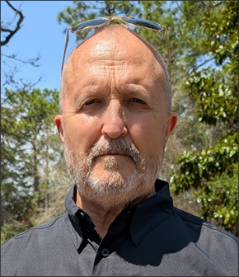
Jim is a retired Pararescueman (PJ) MSgt with 22 years of service; retired due to injuries. His last assignment was with the 58 SOW, Kirtland AFB as the Pararescue and Combat Control program manager. As a PJ, Jim was a Pararescue Instructor, Flight Instructor, Jumpmaster and Divemaster who logged flight time on UH-1N, HH-3E, HH-53E, MH-53J, HH-60G and HC-130P/N aircraft. Jim’s our new Plans and Programs guru.

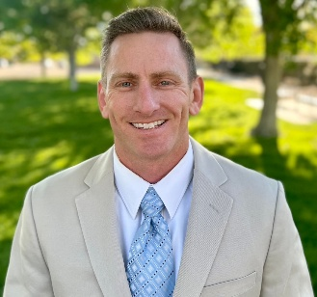
Jim "Tut" Tuthill is a recently retired Lt Col after serving 23 years in the USAF. He was a career HC-130 Navigator/CSO and the lone HC-130J rep on the board. His assignments included the 71 RQS, 550 SOS, 79 RQS, PACAF A8X, 415 SOS, and 512 RQS (HCs and 60s are now combined into the 512 RQS at Kirtland AFB) where he completed his career as an Assistant Director of Operations. Jim’s a new Member-at-Large.

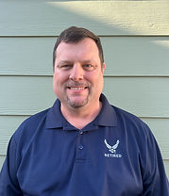
Bill is a retired USAF MSgt and HH-60G Flight Engineer. He served in assignments at the 56th RQS in Iceland (3 tours), 41st RQS Patrick AFB, and the 512 RQS Kirtland AFB. He retired from HQ AETC SOF/CSAR Training in 2009 and is currently working as a civil servant in the 502D Trainer Development Squadron at Randolph AFB. He has assumed the role of our newsletter editor.

Memorial Roster
Editor’s note: please notify the ARA Board via Gene Manner (info@usafrescue.org) if you are aware of the passing of any ARA members
John Flournoy, Jun 18, 2025
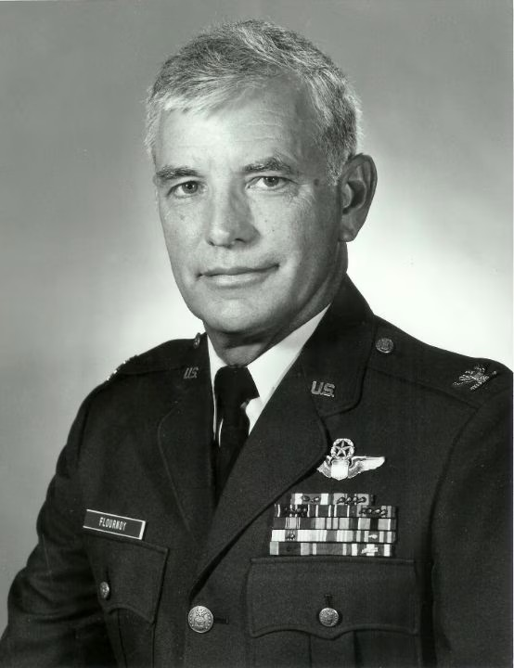

Reunion Sites
Kight Award Winners

Become an ARA Lifetime Member!
Tired of having to get reminded about annual dues? Become an ARA Lifetime Member! It’s easy and just work with Gene Manner (genemanner@gmail.com) on the application. If you’ve paid for this year or more, we can deduct that amount off the total! Lifetime Memberships are available to those at least 70 years of age for $100.00; for those at least 60 for $200.00 and for all others for $300.00. If you’re at least 80, congrats because your Life Membership is free! Life Memberships also include the member’s spouse! Come on in and join the ARA Lifetime Member team!
Air Rescue Association
Application for Membership
Since 1976, and 47 successful reunions later, the Association still seeks and accepts eligible persons who wish to enjoy the camaraderie of “rescue” people. As stated in the bylaws, “Membership in the Association is open to all persons, regardless of grade, rank or position who were or are assigned to the USAF Air Rescue Service or its antecedent and descendent organizations. Other military personnel, government civilian employees, or contractor representatives who were associated with Air Rescue; current and former members of the U.S. Coast Guard and Civil Air Patrol; plus any persons who have been rescued, recovered, or rendered emergency assistance by Air Rescue are also eligible and welcomed for membership. Adult close family members (parents, spouse, children and siblings) of those eligible for membership in accordance with the foregoing are also eligible for regular membership in their own right.” If interested in becoming a member, please supply the information requested in the form below, with a brief summary of applicable Air Rescue service and other pertinent information.
Join online at the following link: https://www.usafrescue.org/membership
Please check all applicable: New Member ___, Update Dues ___, Update Contact ___, Other___
Dues $________for____years. ($10.00 per year [including Spouse] up to 5 years in advance).
Individuals who are at least 80 years old, or have hosted an ARA Reunion, or have paid dues for at least 20 years, or were Life Members of the Jolly Green Ass’n are eligible to become ARA Life Members. (Member must notify the ARA VP, Sec’y or Treas of their eligibility).
Life Memberships are also available to those at least 70 for $100.00; for those at least 60 for $200.00 and for all others for $300.00. Memberships also include the member’s spouse.
My check #________for the total amount of $___________is enclosed. (No cash, please).
_____________________________ __________________ ______________________
Last Name First Name Spouse Name (if applicable)
_________________________________________________________________________________
Address (City, State & Zip)
______________________ ______________________ _____________________________
Home Phone Cell Phone or Fax Email Address
Air Rescue Assignments (Yours or relative’s) Include Unit, Base, State/Country, Years There
Unit 1: _____________________________________________________________________________
Unit 2: _____________________________________________________________________________
Unit 3: _____________________________________________________________________________
Unit 4: _____________________________________________________________________________
If New Member, how did you hear about us? ______________________________________________
Mail this form and check (no cash, please) to: Air Rescue Association
8226 S Diamond H Ranch Place
Vail, AZ 85641
Air Rescue Association Store
If you’d like to purchase some cool USAF Rescue swag, please go check out Undaunted Apparel at https://undauntedclothing.com/product-category/collections/air-rescue-association/
There are great items including hats, mugs, coins and more!
GET SOME RESCUE SWAG
https://www.usafrescue.org/shop

